COMMUNITY CONNECTIONS
Dear Residents,
In the holiday spirit, Merrill City Council is looking for the best Holiday Decorations for 2025. So, put up your lights and decorations because we will have 1st, 2nd and 3rd place awards for the Best of the Best Christmas Display’s. The winners will be announced at the January 14, 2026, City Council meeting.
*******************************************
The City Recorder’s Office will be open from 8:00 am to 12:00 pm on Christmas Eve, Wednesday, December 24, 2025, and will be closed on the following days in observance of:
Christmas Day- Thursday December 25, 2025 New Year’s Eve- Wednesday, December 31, 2025 New Year’s Day- Thursday, January 1, 2026
*******************************************
City Council Meetings are held on the 2nd Wednesday of each month at 6:00 p.m. City Council seeking Budget Committee Members.
Planning Meetings are held on the 1st Monday of each month at 5:30 p.m. located at 301 E. Second Street Merrill, OR 97633.
You can be added to either agenda(s) by contacting the City Recorder's Office, or you can attend and speak during public comment.
___________________________________________
DID YOU KNOW?
Did you know if you have a business or rental within City Limits you are required to have a Business License?
City of Merrill Ordinance No. 252 A, Title XI: Business Regulations: Sections 110: General Licensing Provisions requires anyone conducting business within the City to be licensed.
Applications must be submitted to the City Recorder and are deemed approved when approval is obtained from the City of Merrill Common Council. Licenses shall be valid until the 31st of December following date of issuance. The applicant certifies that he or she will comply with all applicable Federal and State laws as well as all ordinances of the City of Merrill relating to the regulation of his or her business activity.
Business License Fees not paid by February 1st will be assessed a penalty of 5% of that fee per month if the fee remains delinquent. 2026 Business License Renewals will be mailed on December 1, 2025. If you have not received a renewal or submitted an application before, please contact the City Recorder's Office.
___________________________________________
EVENTS & ANNOUNCEMENTS
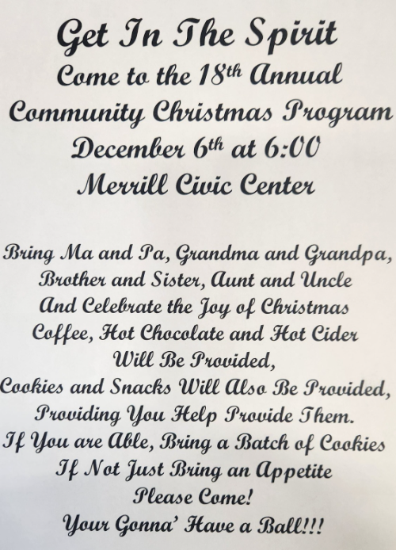
*******************************************
FROSTY THE SNOWMAN
Frosty the snowman was a jolly happy soul,
With a corncob pipe and a button nose,
And two eyes made out of coal.
Frosty the snowman is a fairy tale, they say,
He was made of snow but the children
know how he came to life one day.
There must have been some magic in that
Old silk hat they found.
For when they placed it on his head,
He began to dance around.
O, Frosty the snowman
Was alive as he could be,
And the children say he could laugh
And play just the same as you and me.
Thumpetty thump thump,
Thumpety thump thump,
Look at Frosty go.
Thumpetty thump thump,
Thumpety thump thump,
Over the hills of snow.
___________________________________________
MERRILL HISTORICAL SOCITETY
“CHORES”
Written by
Gregory Matthews
Ya know, I suppose to some folks,
It might seem kind of strange,
The way we spend our Christmases here
At our Home, Home on the Range.
Away from all the hustle and bustle
Of all the big box stores,
Away from the miles of asphalt jungles,
And parking lots full of cars.
Away from the constant clamor,
Away from all the noise,
Away from all the tinsel town Santa’s
Hawking the latest toys.
No, we don’t do much shoppin’
At all them big Mart stores,
We don’t do much of nothin’ at all,
‘Til after we’ve done our chores.
Mama gets the coffee perkin’
Long before sunup,
And then holding the steaming hot pot with her apron Fills our gilded tin cups.
Then she cooks up some biscuits and bacon
Fried spuds and a dozen eggs,
And nobody dare touch a single morsel
‘Til after we’ve bowed our heads.
Pap gives thanks to our Creator in Heaven
For giving us His only Son,
And what a blessed Christmas we’ll all have,
After the chores are done.
I go down to the shed, fire up the Farmall
And load the trailer with hay.
And through the fog of cow’s breath and crystals
I unload our rubber-tired sleigh.
Sis, she feeds the pigs and chickens
And gathers up all the eggs,
Then runs away like a scalded cat
With a rooster peckin’ at her legs.
Mama already has Tom in the oven,
And is makin’ three kinds of pies,
She keeps her big bowl close to the stove
To make sure the yeast rolls rise.
Pap, he’s down feedin’ and pettin’ old Dobbin,
We don’t use him much anymore,
But he’s earned his keep, for he’s done a heap
Of his fair share of the chores.
Finally, it’s time for all of us
To gather ‘round the tree
And tradition calls for everyone to tell,
“What Christmas Means to Me.”
Now comes time to open the presents,
To see what was in Santa’s sack,
A sweater for Mama, a new dress for Sis
And a pair of new gloves for Pap.
Me, I got a new pair of boots
From down at the General Store.
Nothin’ fancy, just some work boots,
Just right, for doin’ the chores.
Then we stuff ourselves and play some games,
Til the evening sun goes down,
Then Mama reads the Bible and tells the story
Of how Christmas came around.
She talks of how Mary was brought to a stable
And there’s where She gave birth,
To a little Baby Boy, The Son of God,
Our Savior here on earth.
Early next mornin’ I’m still thinkin’
About Mary and God’s only Son,
And it makes it a little easier,
While lacing my boots,
To make sure the chores get done.
___________________________________________
BIRTHDAYS, ANNIVERSARIES & SPECIAL DAYS
Happy Birthday and Anniversary to City of Merrill Residents!
We'd love to share your memorable occasions, crafts, and food ideas with the community.
Please send a note, call 541-798-5808, visit the Recorder’s Office or send an email to clerk@cityofmerrill.org.

